Sentiment Analysis of Twitter Data using Machine Learning Approaches

Abdullahil Kafi
Under-Graduate Student
Department of Computer Science and Engineering
BRAC University
Dhaka, Bangladesh

M. Shaikh Ashikul Alam
Under-Graduate Student
Department of Computer Science and Engineering
BRAC University
Dhaka, Bangladesh
Sayeed Bin Hossain
Under-Graduate Student
Department of Computer Science and Engineering
BRAC University
Dhaka, Bangladesh

Siam Bin Awal
Under-Graduate Student
Department of Computer Science and Engineering
BRAC University
Dhaka, Bangladesh

Abstract—Today Microblogging has become a very popular way to represent opinions of different aspects of life among internet users. Therefore, it has become a good source of data for sentiment analysis. Twitter is very familiar microblogging site to discover what is happening around the world at any moment. This paper focuses on using Twitter for the task of sentiment analysis. The proposed system automatically finds the sentiments of opinions. To develop the system, the data is pre-processed first by NLP and using pre-processed data, sentiment scorings is figured out using many machine learning algorithms, that is able to determine positive, negative and neutral sentiments for a twitter post.
Keywords—Sentiment Analysis; Machine Learning; Natural Language processing

Introduction
The desire to be connected at all times, whether through a computer or a mobile device, or something else is now very common phenomena to Internet Users. Microblogging is one of the best way for Internet users to be connected at any moment throughout the whole day. In a single day, Millions of opinions or messages are posted by the users in microblogging sites like Twitter, Facebook etc. Users are free to post their opinions on various aspects of current issues, share their experiences throughout the day, express emotions about their countries and beloved people. Furthermore, Microblogging like twitter is easily accessible to all aged people around the world, that’s why people are altering to use microblogging rather than mails or other traditional ways of communications. The number of Twitter users reached an estimated 330 million by the end of 2017 and it is a huge platform for communication. This has been a valuable source for people’s opinions and sentiments. Such data can be efficiently used for research purposes and analysis. We use a dataset formed of collected posts from Twitter. Twitter contains a very large number of very short messages created by the users. The contents of the messages vary from personal thoughts and public statements. Using these data, we try to analysis sentiments of twitter posts.
The rest of the paper is organized as below. In section 2, we present some background story and related works. Section 3 presents the overview of different machine learning algorithms. In section 4, we try to represent comparisons among multiple algorithms on sentiment Scorings. We discuss about results in section 5 and section 6 concludes our paper with some discussions and future aim of ours on this project.

Background Study
There has been an enormous development in the utilization of micro-blogging platform, such as Twitter, and different companies and media organizations are looking for ways to extract information from these micro-blogging platforms to understand what people think and feel about their products and services [1]. With more people getting involved with micro-blogging platforms, sentiment analysis, which is aa evolving area of natural language processing, is becoming a field of interest for many researches [2].
There have been numerous papers looking at and working with Twitter sentiment and buzz in the past few years [2,3,4, 5]. Many researchers have started to use part-of-speech feature to analyze sentiment but the result remain mixed.
To construct corpora for sentiment analysis, web-blogs are used and emotion icons assigned to blog posts are used as indicators of user’s emotion and mood. Applying SVM and CRF learners, sentiments are classified at the sentence level and by exploring different strategies, overall sentiment of the document is determined [6].
Many researchers have now started to explore different methods to gather training data automatically. To define training data, some researchers depend on emoticons. On the other hand, some researchers use hashtags for creating training data but rather than 3-way polarity classification, they limit their research to sentiment/non-sentiment [7].

Working Principle
This study was conducted in the department of computer science and engineering, BRAC university during the year 2018. Sentiment analysis is a very useful tool in modern technological era. Analyzing a sentiment helps human being to take a decision very easily in case of socio-economic and business aspects. In this study the authors used natural language processing along with machine learning tools to find out the sentiment and accuracy depending on the algorithm. The authors used many machine learning algorithms, such as Naïve Bayes Classifier, Linear Regression, Support Vector Classifier as well as RNN and LSTM were applied for finding out the accuracy of the sentiment analysis. A schematic diagram is given below to show the proposed model of sentiment analysis,
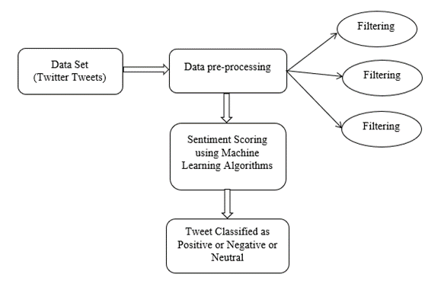
- Schematic diagram of proposed model.

Data
For sentiment analysis and accuracy testing using machine learning the most important thing is the dataset. The authors used three different datasets for training and testing and measured the accuracy of the algorithms after training with training dataset.

Text-Preprocessing
The authors used text preprocessing to prepare the dataset. Natural language processing toolkit is used to pre-process the data. Mostly tweets consist of message along with usernames, special character, stop words, emoticons, hash tags, time stamps, URL’s etc. Thus, to make this data fit for mining authors pre-process this data by using various function of NLTK. In pre-processing extracting main message from the tweet, then removing the unwanted words or characters and then replacing all emoticons and abbreviations with their corresponding meanings is the first task. Once these are done the preprocessed tweet is clean. Sample tweet and processed tweet. Cleaning of twitter data is necessary since tweets contain several syntactic features that may not be useful for analysis. The pre-processing is done in such a way that data represented only in terms of words that can easily classify the class. Next, the texts are tokenized by splitting the text into spaces and punctuations marks and then from bundle of words, in this case the authors used library to tokenize the tweet.

Classification Data
For sentiment analysis and accuracy testing using machine learning the most important thing is the dataset. The authors used three different datasets for training and testing and measured the accuracy of the algorithms after training with training dataset.

Naïve Bayes Classifier: Naïve Bayes Classifiers are probabilistic classifiers which come under machine learning technique. These classifiers are based on applying the Bayes’ theorem with strong (naïve) assumption of independence between each pair of features. Let us assume, there is a dependent vector from x1 to xn and a class variable ‘y’. So, according to Bayes’ theorem,

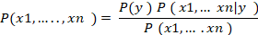
The proposed classifier is used to predict the probability for a given words belonging to a particular class. It is used because it is easy to train and find out the classification. Pre-processed data is given as an input to train the classifier and that is applied on test set to generate either positive, negative or neutral sentiment.

MultinomialNB Classifier: Multinomial Naïve Bayes classifier is the expansion of the Naïve Bayes classifier. It implements the naive Bayes algorithm for multinomially distributed data and is one of the two classic naive Bayes variants used in text classification. Scikit learn has a library for the MNB classifier and the train set is applied to train the classifier. After the training the test set is applied for getting the polarity of the tweet.

The authors have also used Linier Regression, Support Vector Classifier (SVC).

Result and discussion
In the proposed system, Python is used for implementation and the dataset is collected form online. To find the accuracy of the algorithm used the authors used an evaluation equation. Accuracy is the performance evaluation parameter and it is calculated by number of correctly selected positive and negative words divide by total number of words present in the corpus. The formula of is given below,
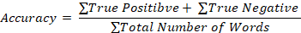
Here, true positive is the number of tweets recognized as positive and true negative is the number of tweets recognized as negative.
The accuracy scored by different machine learning algorithms on our test data is shown in the table below,
TABLE I. Accuracy of Machine Learning Algorithms
Machine Learning Algorithms | Accuracy (in percent)
Naïve Bayes | 63.87911405506106
Multinomia Naïve Bayes | 63.661767749948254
Linear SVC | 61.84019871662182
Logistic Regression | 63.33057338025253
BernoulliNB | 61.49865452287311
SGD Classifier | 61.61250258745601

The authors found out 10621 feature sets, the positive and negative words using the machine learning algorithms. Moreover, the model is also tested with live tweet posts and the accuracy is average in that case. Here is an example of a tweet, "He is an incapable person. His projects are totally senseless." And this tweet is given a score of 90% negative.
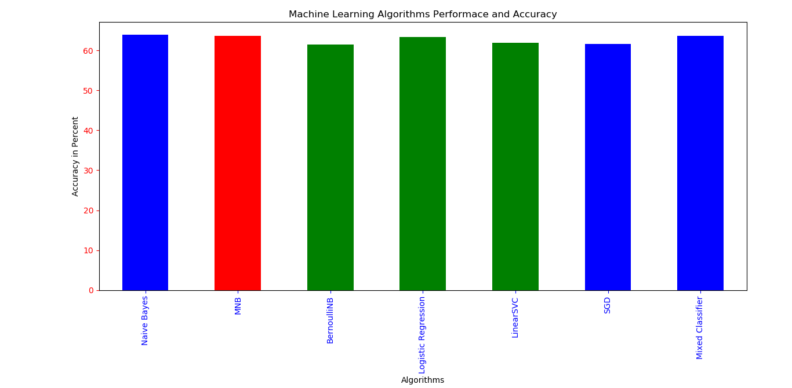
- Machine Learning algorithms Accuracy
In Fig 2 the models accuracy is shown in a graph. The accuracy of the model is upto ~65% which is a good score in terms of the algorithms used. The models, mixed classifier has a accuracy of ~63%. As the train set was only 1000 the test accuracy is low, however the accuracy increases if the test set is larger.

Conclusion
In this paper, the performance of Naive Bayes, Support Vector Machine (SVM), Linear Models for sentiment analysis of tweets have been analyzed. Comparing the accuracy of the different approaches, results are presented in this paper. The performance of different machine learning techniques should be explored widely using diverse datasets. In addition to this, comparative analysis among different machine learning techniques, which algorithms performs accurate on which type of dataset and why, this paper can be used as a base of further investigation. And in future work, RNN and LSTM can be applied to further calculate accuracy and compare with other machine learning techniques.

Acknowledgment
The authors completed the research work not only by the combined efforts of all the authors but also by the help and guidance of their coordinates, Assistant Professor Iftekharul Mobin and Assistant Professor Dr. Mohammad Zavid Parvez. The authors thank them for their comments that greatly improved the research work. Moreover, the authors are also grateful to BRAC University and the Department of Computer Science and Engineering for developing such a curriculum that aids Undergraduate Students to accomplish successful research work.

References
- E. Kouloumpis, T. Wilson, and J. Moore, “Twitter Sentiment Analysis: The Good the Bad and the OMG!,” Fifth International AAAI Conference on Weblogs and Social Media, July 2011.
- A. Pak, P. Paroubek, “Twitter as a Corpus for Sentiment Analysis and Opinion Mining,” Processdings of LREC, January 2010.
- B.J. Jansen, M. Zhang, K. Sobel, A. Chowdhury, “Twitter Power: Tweets as Electonic Word of Mouth,” Journal of the American Society for Information Science and Technology, 60(11):2167-2188, 2009
- B. O’Connor, R. Balasubramanyan, B.R. Routledge, N.A. Smith, “From Tweets to Polls: Linking Text Sentiment to Public Opinion Time Series.” International AAAI Conference on Weblogs and Social Media, 2010
- A. Tumasjan, T.O. Sprenger, P.G. Sandner, I.M. Welpe, “Predicting Elections with Twitter: What 140 Characters Reveal about Political Sentiment,” Journal Of The International Linguistic Association, 2010
- C. Yang, K.H.Y. Lin, H.H. Chen, “Emotion Classfication Using Web Blog Corpora,” 275-278. 10.1109/WI.51, 2007
- D. Davidov, O. Tsur, A. Rappoport, “Enhanced Sentiment Learning Using Twitter Hashtags and Smileys,” 23rd International Conference on Computational Linguistics, Proceedings of the Conference. 2. 241-249, 2010

